Circle the types of stories you like to watch/ listen to or read.
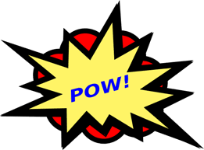  Action |   Romance | 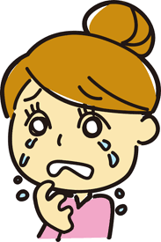  Drama | 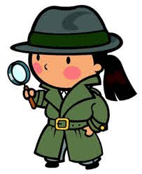  Suspense | 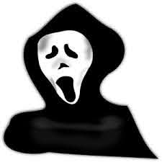  Scary | 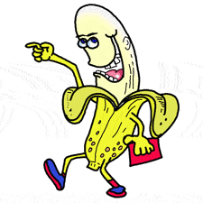Comedy
Circle the Reasons to Read that most connect to you
To learn about new places, things, people, or ideas. | To read about historical events/ learn about the past. | To hear the stories of others. | To escape into another reality. | To pass the time. | To laugh.
Name two places you like to read: |  | Name the last two books you read (in school or on your own) |  | List two things that might stop you from reading:

Name: _____________________________ Date: _____________________
Self-Selected Text Reading Form
Title of Book: |  | Author: |  | Pages read today:
Why did you select this book?

Main Character (and description): |  | 1-3 Supporting Characters (and descriptions):
Summarize the action in today’s reading using (Somebody, Wanted, But, So, Then):
- S:
- W:
- B:
- S:
- T:
What is the setting of this story?  - Where:  - When: |  |  | So far, what is the main conflict?
Identify 2- 3 words from today’s reading.  - Use context to infer their meaning: |  | Word:  Meaning: | Word:  Meaning | Word:  Meaning:
What was the most interesting part of your text today? Why did you select this part?

What will you predict will happen next in the text?

